Statement of Significance: Hampden Road Precinct, Armadale, January, 2024
Heritage Place: Hampden Road Precinct, Armadale | PS ref no: HO136
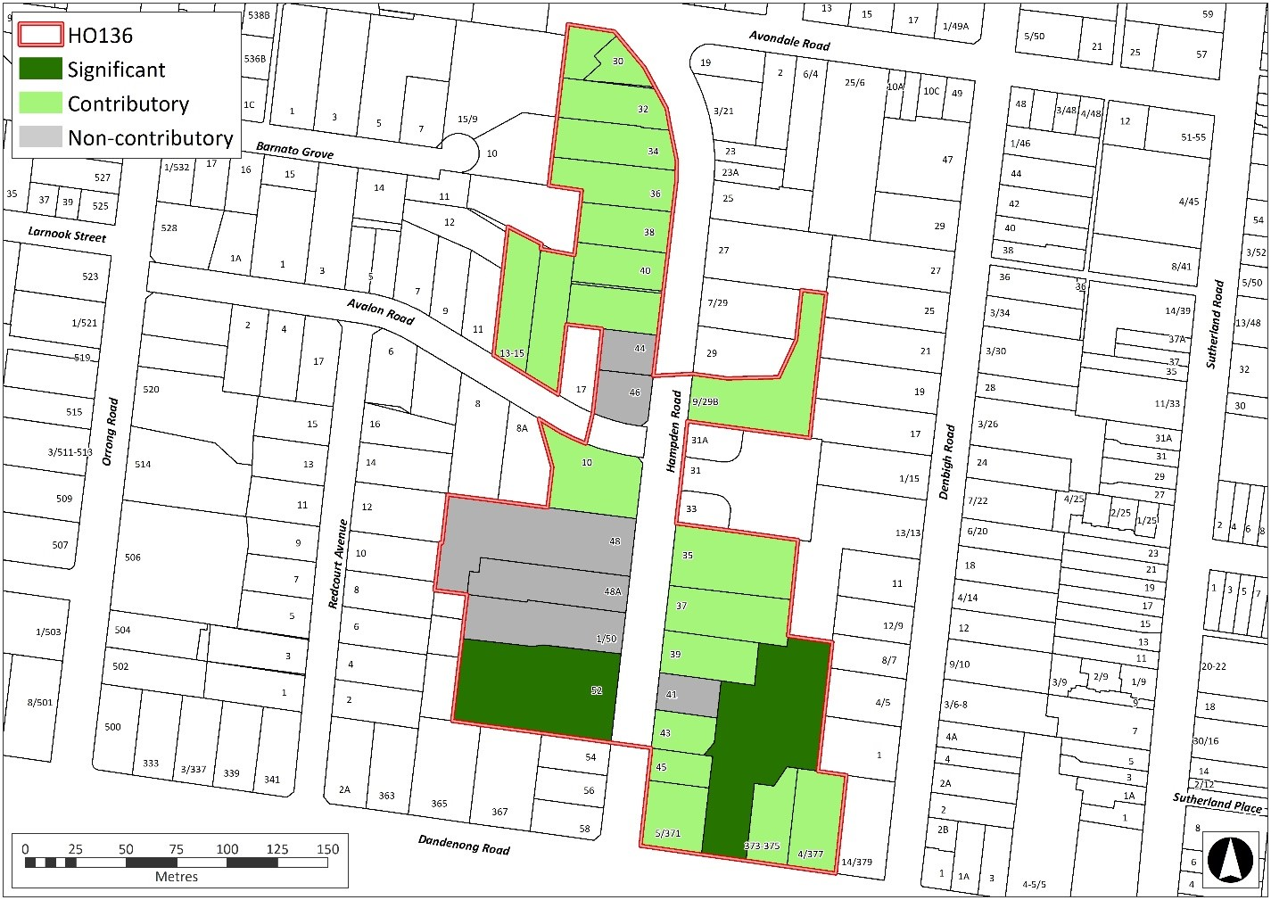
What is significant?
The Hampden Road Precinct, comprising properties on Hampden Road, Avalon Road and Dandenong Road, is locally significant. The mature oak (Quercus) street trees on Hampden Road are also locally significant.

Significant properties include:
- Former Moorilim, 373-375 Dandenong Road, Armadale (Victorian Italianate mansion, now a school)
- Namarong, 52 Hampden Road, Armadale (Victorian Italianate mansion)

The remainder of the precinct is predominantly characterised by contributory graded buildings, with a small number of non-contributory infill developments. Refer to the grading map for designations.

Character elements that contribute to the significance of the precinct include:
- The generous allotments established by the 1919 subdivision of Namarong Estate and 1929 subdivision of Avalon Estate;
- The presence of intact remnant late Victorian Italianate mansion estate buildings, that were erected prior to the interwar era subdivision;
- The presence of a large group of contributory dwellings of varying Interwar styles, including Old English, Georgian Revival (with Mediterranean influences), American Bungalow, Mediterranean and Streamline Moderne. Some of these buildings are associated with notable architects.
- The relatively high integrity of contributory buildings when viewed from the street. Dwellings typically survive with their presentation to the street largely unaltered, retaining elements such as verandahs, porticos, roof forms, chimneys, windows and door openings, brick detailing and timber joinery;
- The overall consistency of form, scale (one to two storeys), siting (regular front and side setbacks) and external materials and detailing (brick or render with hip or gable tiled roofs and chimneys) of the groups of interwar houses, apartments and maisonettes;
- Building designs reflecting the growing popularity of interwar high density flat development;
- Building designs responding to the rise in popularity of the motor car;
- The absence of vehicle accommodation or other buildings in front or side setback areas; and
- A garden estate character established by the well-maintained garden settings, low front fences and street trees, particularly the mature oak (Quercus) trees.

Later alterations and additions to the properties are not significant.
How is it significant?
The Hampden Road Precinct is of local historical and aesthetic significance to the City of Stonnington. The precinct also has associative significance, featuring an example of domestic architecture by a notable architect.

Why is it significant?
The Hampden Road Precinct is historically significant as interwar subdivisions of the Namarong Estate and Avalon Estate respectively, which saw the formation of a wide street with generous allotments within Armadale. Both the remnant late Victorian dwellings and diversity of interwar houses and flats erected following the subdivision demonstrates urban character changes that occurred between the late 19th and early to mid 20th century in the City of Stonnington. It is also significant as an illustration of the increasing popularity of apartment living during the inter-war period and, in particular, demonstrates the emergence of maisonettes as an acceptable form of apartment development for middle class families. The precinct forms a tangible link to the interwar subdivision and development story of Armadale. (Criterion A)

The Hampden Road Precinct is aesthetically significant an intact and visually cohesive residential streetscape characterised by a large number of fine, well-detailed and cohesive freestanding residences, apartment buildings and maisonettes from the interwar era, including several examples designed by notable architects from the period. These buildings are designed in the interwar Old English, Georgian Revival (with Mediterranean influences), American Bungalow, Mediterranean and Streamline Moderne styles, and display cohesion through built form, materials, siting, setbacks and heights. The elegant detailing and complementary scale, forms and materials of the Victorian Italianate mansions also enhance the aesthetic significance of the place These features, combined with the strong garden estate character established by well-maintained gardens, low front fences and street trees, particularly the mature oak (Quercus) trees, combine to form a harmonious and attractive residential area. (Criterion E)

The Hampden Road Precinct has associative significance, featuring an example of the domestic Interwar work of noted architect Arnaud E. Wright (13-15 Avalon Road). (Criterion H)

Grades

Place address | Proposed Grading
9/29B Hampden Road | Contributory
30 Hampden Road | Contributory
32 Hampden Road | Contributory
34 Hampden Road | Contributory
35 Hampden Road | Contributory
36 Hampden Road | Contributory
37 Hampden Road | Contributory
38 Hampden Road | Contributory
39 Hampden Road | Contributory
40 Hampden Road | Contributory
41 Hampden Road | Non-contributory
42 Hampden Road | Contributory
43 Hampden Road | Contributory
44 Hampden Road | Non-contributory
45 Hampden Road | Contributory
46 Hampden Road | Non-contributory
48 Hampden Road | Non-contributory
48/A Hampden Road | Non-contributory
1/50 Hampden Road | Non-contributory
52 Hampden Road | Significant
10 Avalon Road | Contributory
13-15 Avalon Road | Contributory
5/371 Dandenong Road | Contributory
373-375 Dandenong Road | Significant
375 Dandenong Road | Contributory
4/377 Dandenong Road | Contributory

* S: Individually significant
C: Contributory
NC: Non-contributory
Refer to Heritage Victoria’s Model brief for consultants (p.6) for explanation of designations.
Primary source
Hampden Road Precinct, Armadale, Citation Report, Extent Heritage Pty Ltd, January 2024..
February 2019

